19th September 2016

BARCELONA TO DECIDE SEAT LEON EUROCUP TITLE

For the third consecutive season, the SEAT Leon Eurocup International series with YOKOHAMA as exclusive tyre supplier visited the Nürburgring in Germany. At the weekend the single make trophy offered some exciting motor racing and now boasts three drivers with options to the Championship in the final race weekend of the year.

In November all the hard work and efforts and hope and expectations from the different teams will come to a dramatic two final races in Barcelona. With full action at the Nürburgring 14 drivers were present at the legendary race track, with bumper to bumper action in each of the races.

The Spanish driver Mikel Azcona showed once again his determination to aim for the top spot, and led the practice and the qualifying session to achieve a meritorious pole position. Azcona led the first race from lights to flag and managed an impressive victory with five seconds advantage over runner up Alex Morgan and six seconds over the current Championship leader, Niels Langeveld.

Sunday’s race had to be delayed for 40 minutes due to thick fog which is a common occurrence at the “Green Hell”. Once the race got underway, it was exciting. Baporo Motorsport’s Alessandro Sebasti Scalera took advantage of the inverted grid to lead the race and take the victory, while the Norwegian Stian Paulsen followed in second and Julien Briche in third.

After the Nürburgring races, Niels Langeveld still leads the Championship with 202 points, followed by Stian Paulsen with 191 and Mikel Azcona with 185. The top three, separated by a few points only will have an intense battle for the title at the last round of the SEAT Leon Eurocup, to be held in Barcelona on the 5th and 6th of November.

Race 1:
1. Mikel Azcona (#1), PCR Sport; 26’01.067
2. Alex Morgan (#5), Wolf-Power Racing; +5.214
3. Niels Langeveld (#10), Baporo Motorsport; +6.116
4. Julien Briché (#3), JSB Competition; +7.041
5. Stian Paulsen (#34), Stian Paulsen Racing; +18.313

Race 2:
1. Alessandro Sebasti Scalera (#7), Baporo Motorsport; 26’12.699
2. Stian Paulsen (#34), Stian Paulsen Racing; +2.790
3. Julien Briché (#3), JSB Competition; +5.277
4. Niels Langeveld (#10), Baporo Motorsport; +9.320

2016 SEAT Leon Eurocup Overall standings
1. Niels Langeveld (#10), Baporo Motorsport; 202 points
2. Stian Paulsen (#34), Stian Paulsen Racing; 191 points
3. Mikel Azcona (#1), PCR Sport; 185 points

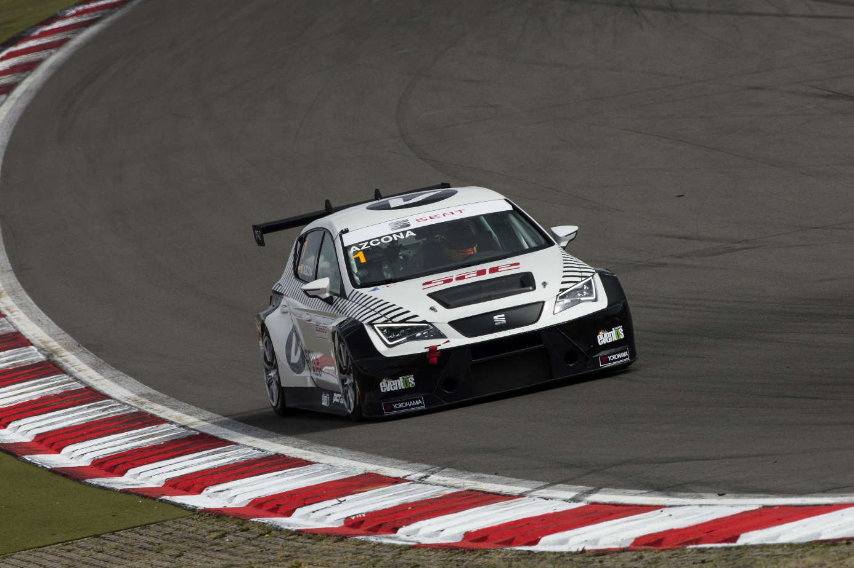
SEAT León Eurocup - Mikel Azcona

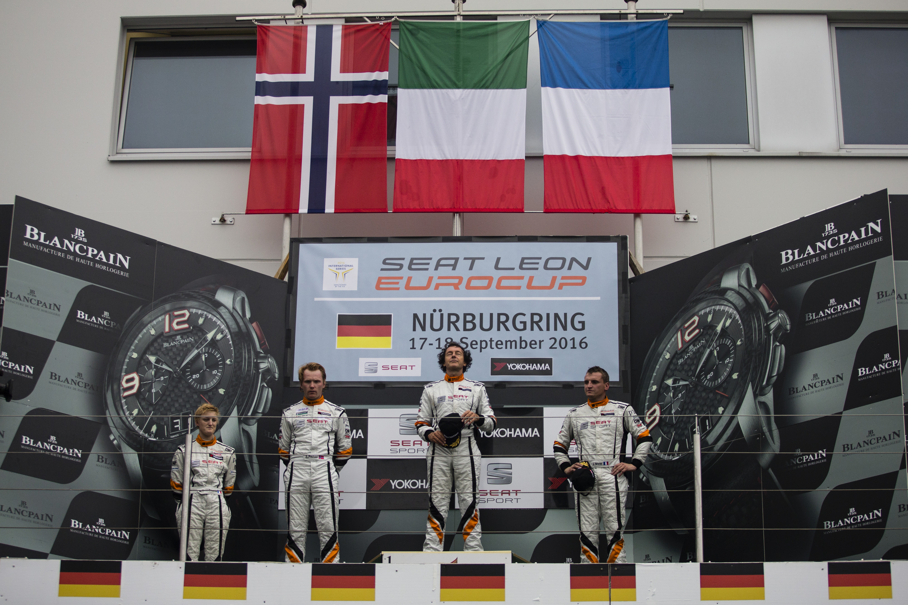
SEAT Leon Eurocup - Nurburgring Podium

